3)List theempsin theascorder of their Salarie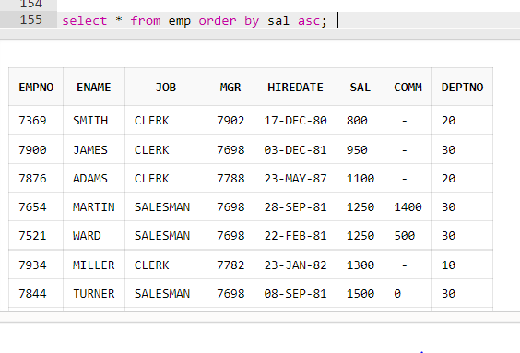

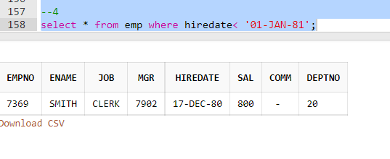

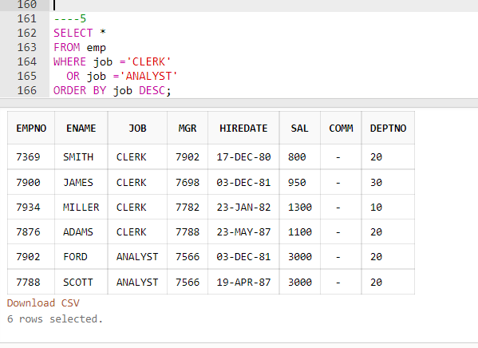

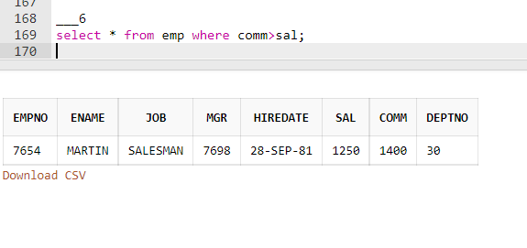

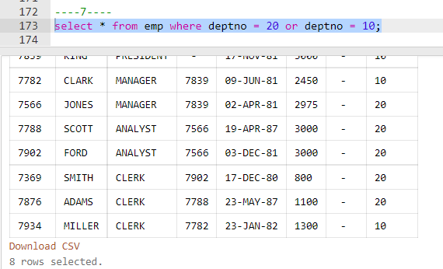

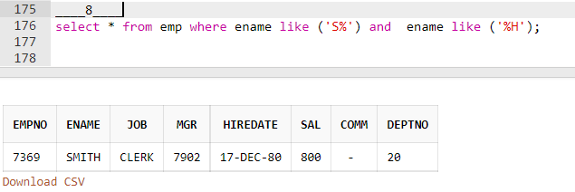

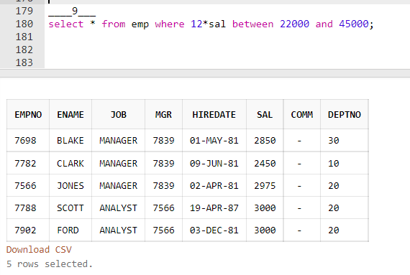

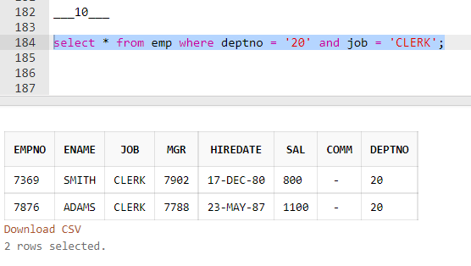

11)Find the highest sal of EMP table.

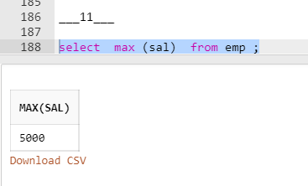

12)Display the average salaries of all the clerks.

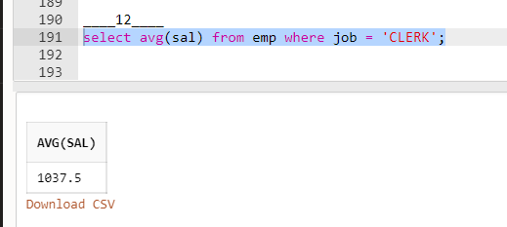

13)List the emps whose names contains ‘A

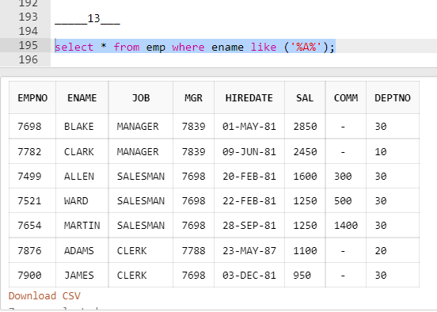

14)Print the details of all the emps who are sub-ordinates to Blake.

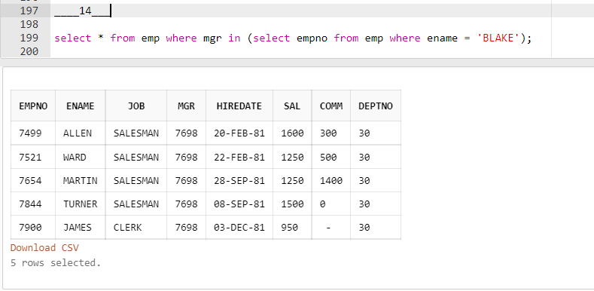

15)List the no. of emps in each department

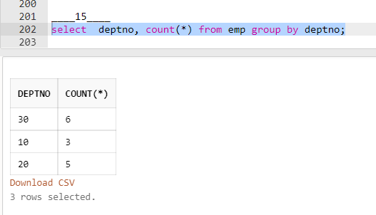

16)List the employee names and his average salary department wise

A) Find who is making Max Salary in Department 30   (use child query)  
  
  
B) Find who are working in New York (use child query)  
  
  
C) Find who are making more than Average Salary in Department 10 (use child query)  
  
  
D) Show **Ename, SAL,  LOC** for Department 10 and 20  (perform join)  
  
  
E) Show how many employees work for each department has  (use group by command)  
  
  
F) Show how many employee lives in each City (grouping)